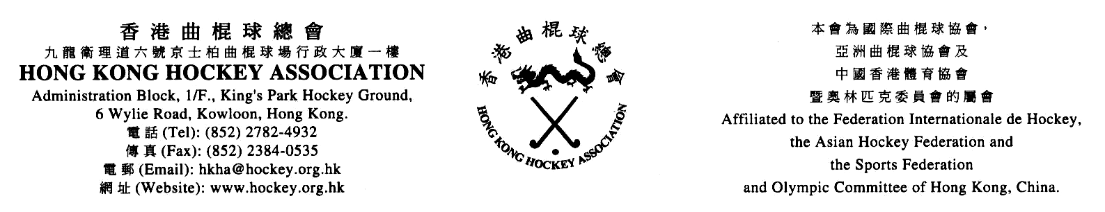

HONG KONG HOCKEY ASSOCIATION
WOMEN’S SECTION

List of Nominations for 2017-18

Post |  | Nominee |  | Proposed by |  | Seconded by
 | Chairman |  | Rhona Barr |  | Leena Madhvani |  | Kitty Yau
 | Vice-Chairman |  | Noel Chau |  | Kitty Yau |  | Chan Ka Yee
 | Hon. Secretary
 | Hon. Treasurer |  | Yii Sui Suet |  | Eva Thometz |  | Eunice Tong
 | Registrar
 | Grounds & Fixtures Secretary |  | Leela Patel |  | See Wai Ki Rinky |  | Leena Madhvani
 | Umpires Secretary |  | Kitty Yau |  | Chan Ka Yee |  | Noel Chau
 | Tournaments Secretary |  | Eunice Tong |  | Eva Thometz |  | Heather Galbraith
 | Committee Member (Liaison Officer) |  | Karina Lam |  | Kitty Yau |  | Kathy Chan
 | Committee Member (Social Media) |  | Chan Ka Yee |  | Kitty Yau |  | Karina Lam
 | Committee Member |  | Christine Wood |  | Kelsey Dunn |  | Leena Madhvani
 | Committee Member |  | Mok Ka Man |  | Kitty Yau |  | Chan Ka Yee
 | Committee Member |  | Chow Wing Man |  | Sophie Lau |  | See Wai Ki Rinky
 | Committee Member |  | Heather Galbraith |  | Eva Thometz |  | Eunice Tong
 | Committee Member |  | Jane Farrelly |  | Sophie Lau |  | See Wai Ki Rinky

